Secret Valley
Elijah Gill and Dahlia Mihalic
Project Checkpoint 2: Site Sketch

Page 1: Homepage (Homepage.jsx)
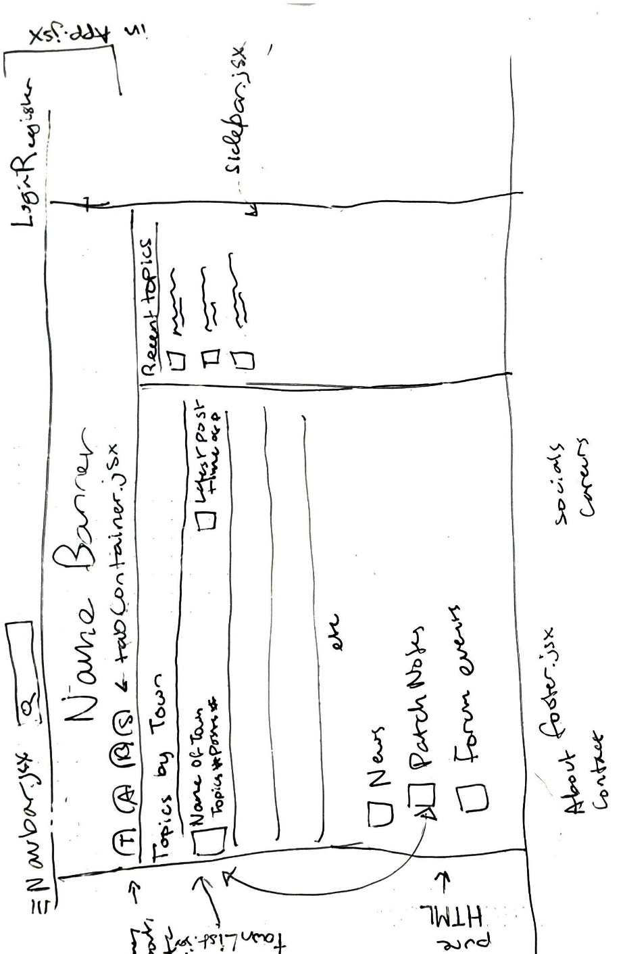
- Navbar.jsx (located in App.jsx)
  - Holds the home page and login links and search bar for threads, conditionally will change to Logout and My Posts when logged in
- Sidebar.jsx:
  - Holds recent topics for easy access
- TabContainer.jsx (located in App.jsx)
  - Holds navigation for Home, What’s New, Trending, etc
- TownList.jsx:
  - A form of topicsList which holds trending based on the town it’s from in-game.
- Footer.jsx: (located in App.jsx)
  - A footer containing helpful links

Page 2: Topics List / My Posts
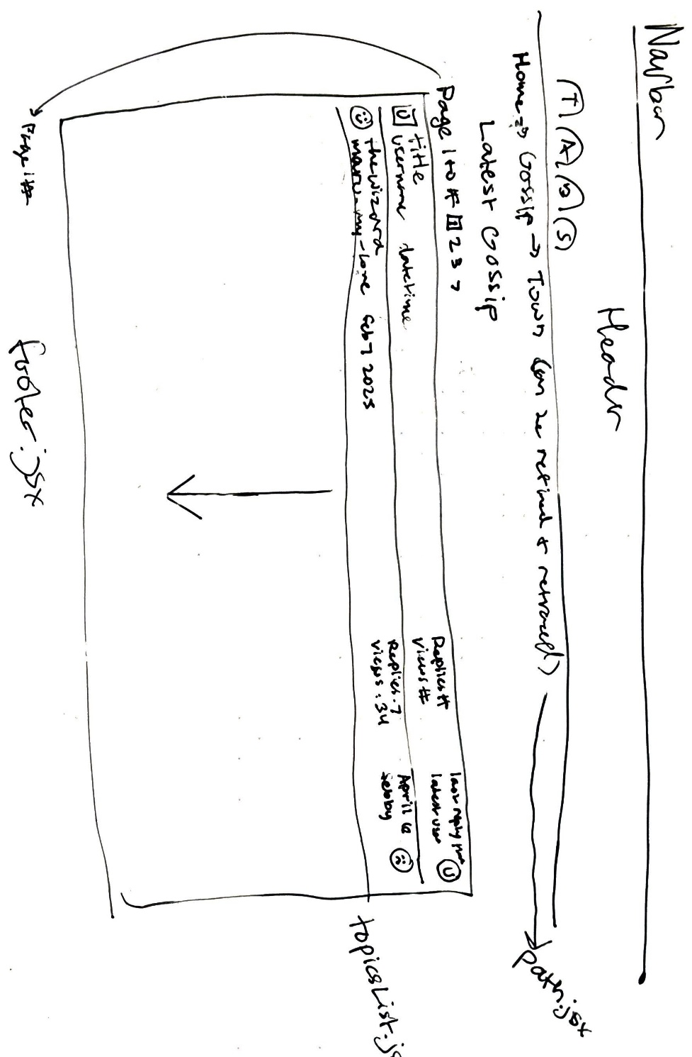
- Path.jsx:
  - Holds the navigation information so that users can quickly and easily retrace their steps
- TopicsList.jsx:
  - Holds a list of topics and information about the post engagement, the user who posted it, and the user who last replied
  - Has pages and page navigation
- When in My Posts mode, it will show all the topics that the user has posted or replied to.
ForumPostPage.jsx
- ForumPost.jsx holds the profile photo of the character, the character’s name, and the username of the poster as well as the post text
- Has page navigation and a title as well as the time posted
- Replies are below the main post but in the same format
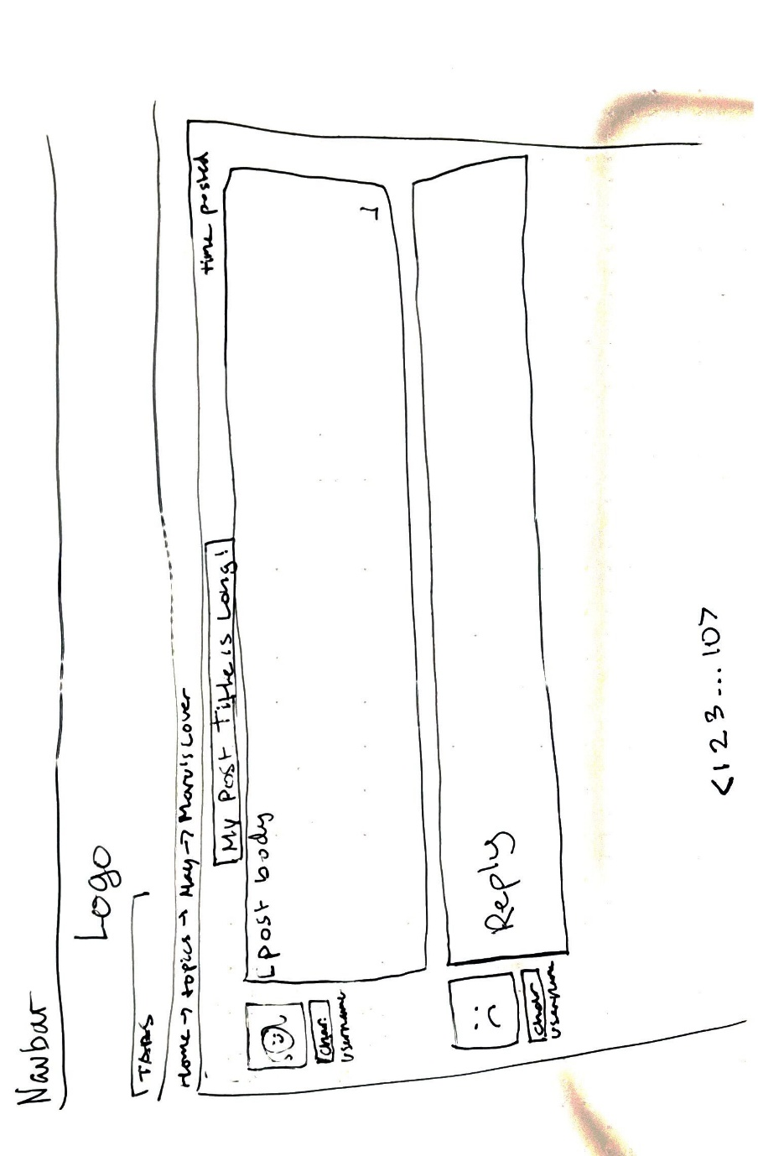
LoginPage.jsx/RegisterPage.jsx:
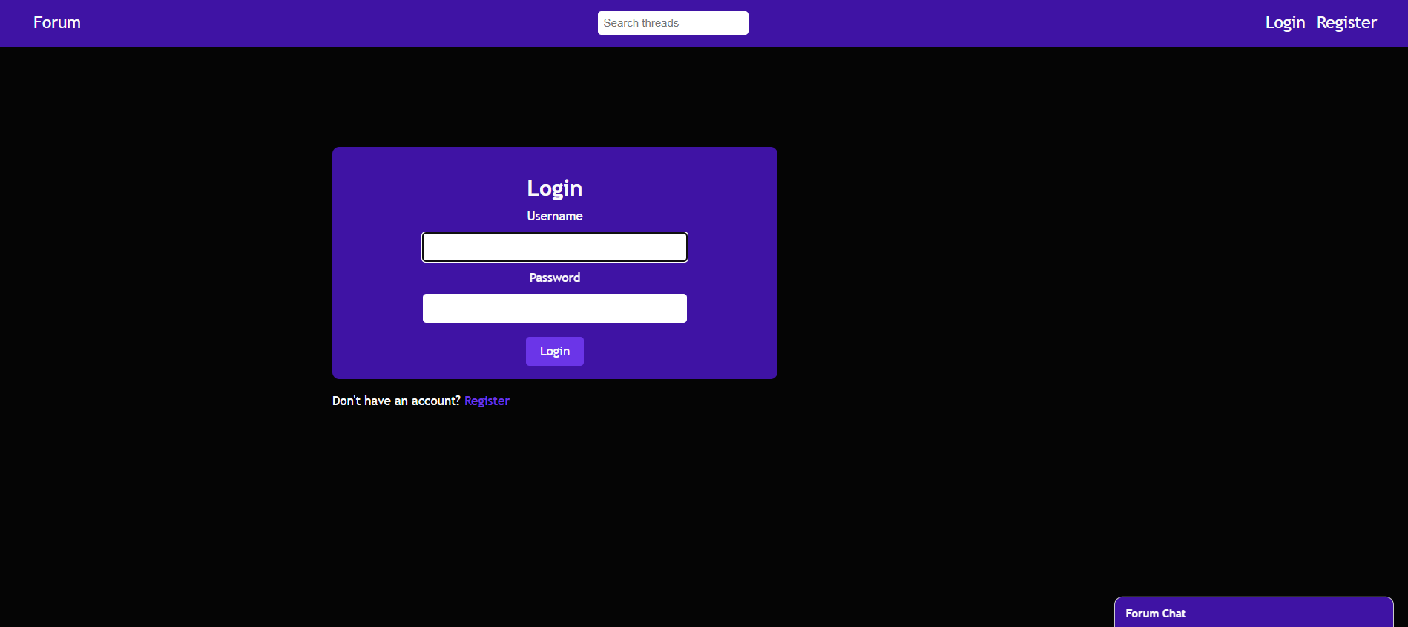
- LoginForm.jsx: uses context and hooks to log the user in
- Has a link to register which has conditional formatting to add an email input
ChatWindow.jsx:
- A global chat window, hidden on click
